Name: Kainaat Rafiq Hussain Makhani
Registration Number: 2012296
Semester and Section: 7A
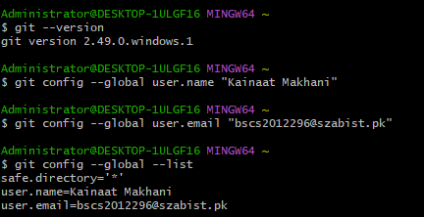
Github Lab Assignment

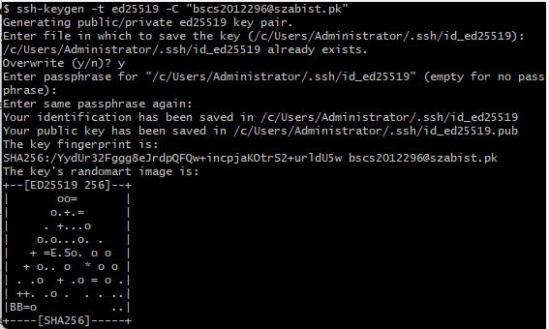

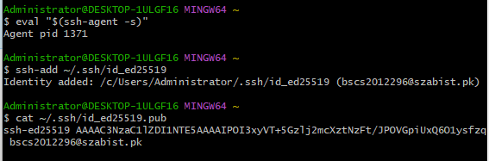

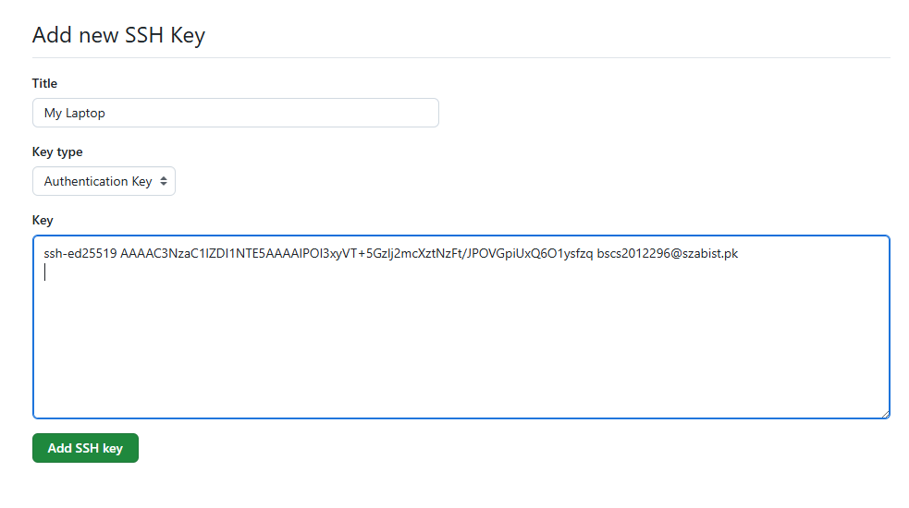

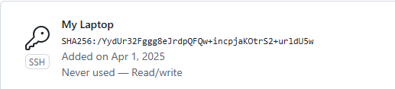

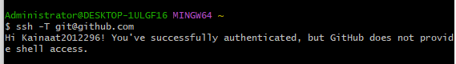

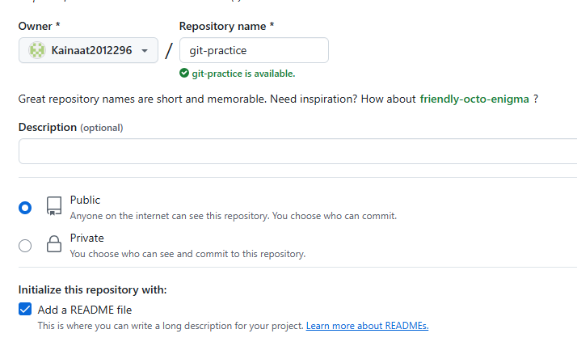

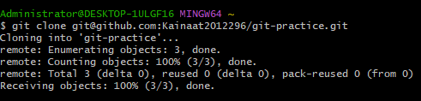

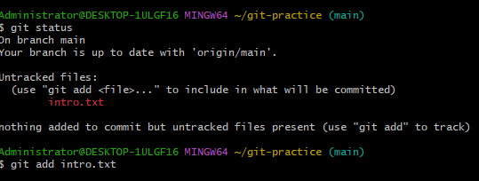

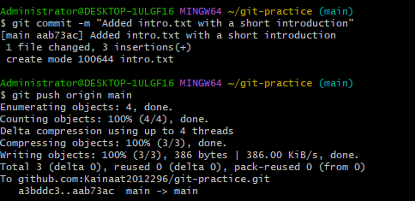

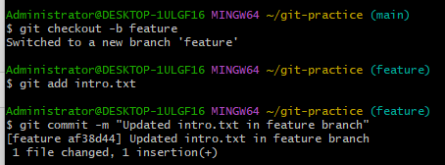

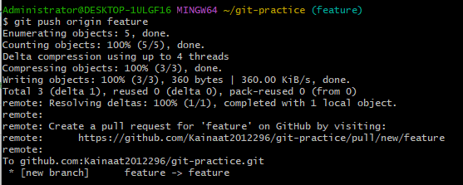

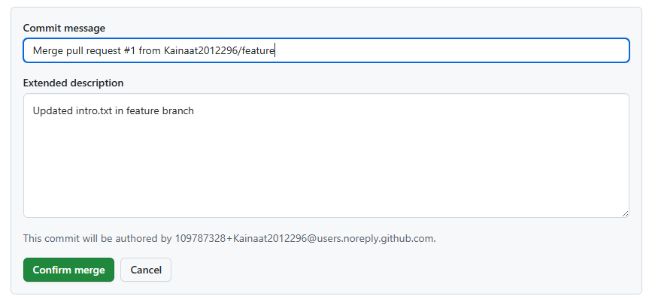

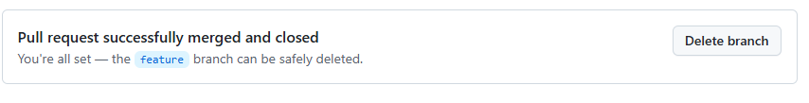

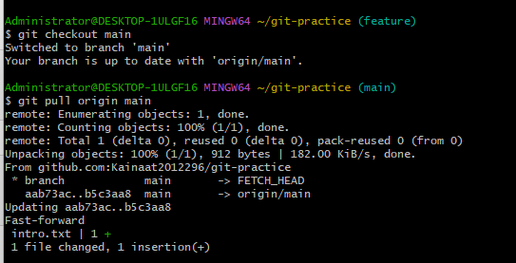

Description:
In this lab, we learned how to configure Git on a local machine by setting up the user name and email. We generated an SSH key and added it to our GitHub account for secure authentication. A new repository was created and cloned to the local system. Then, we created a new file, made changes, and committed them using Git commands. This lab helped us understand the basic workflow of Git and how to connect our local environment with GitHub.

